**Lab 2**

id:7   
name: Harshil Patel

**objective**

creating an end to end system to get data from different type of sensor and send that data to node-red to visualize data and then pass the data to twitter in form of tweets.

**Flow**

1. Connect different type of sensor(temperature,dust,light and etc) with arduino.
2. Create serial-in node to get data from arduino to node-red.
3. create a function node to parse the serial data coming from arduino and generate charts.
4. create a tweet node in node-red to pass the data to twitter in form of tweet.

**CKT diagram**

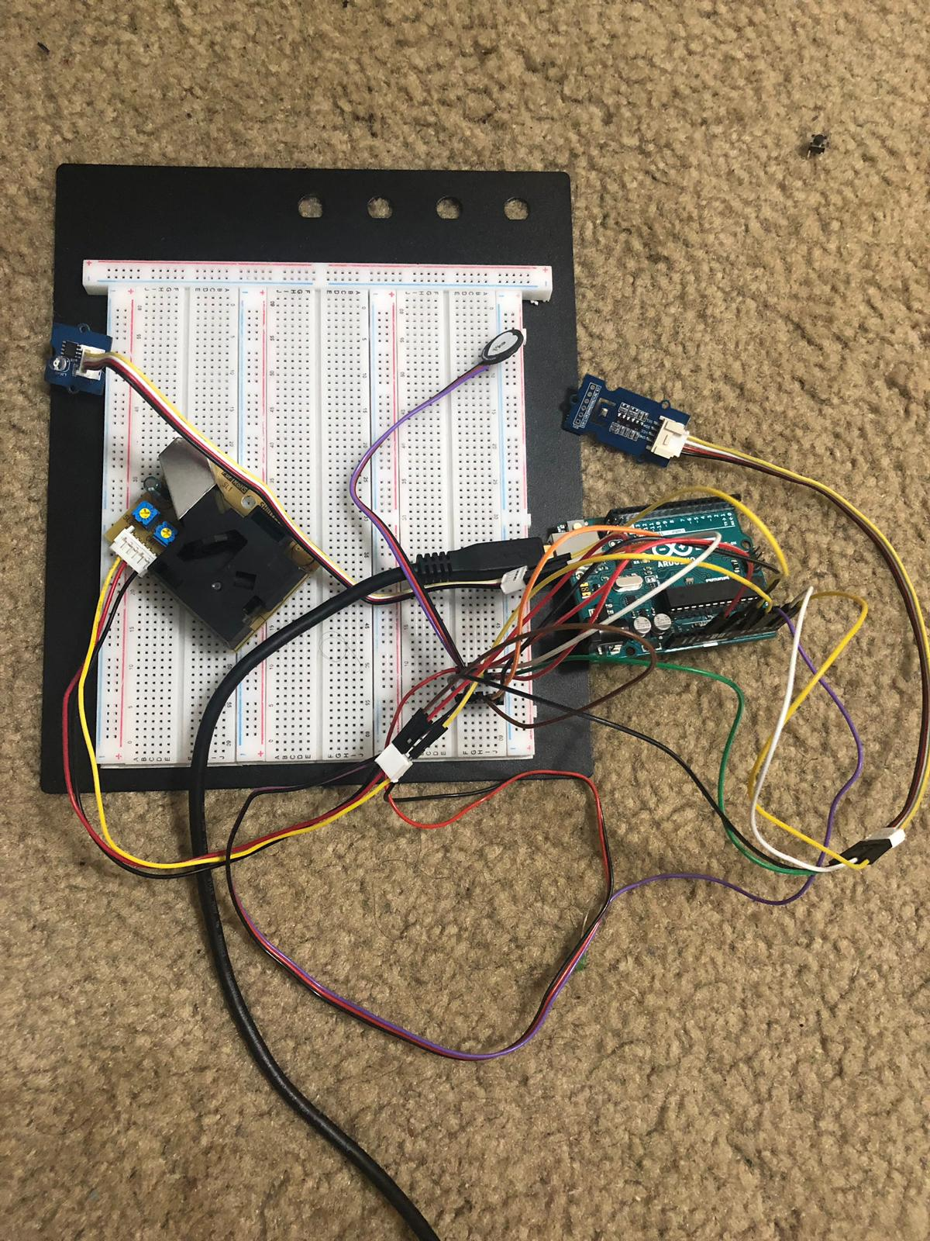

**arduino code**

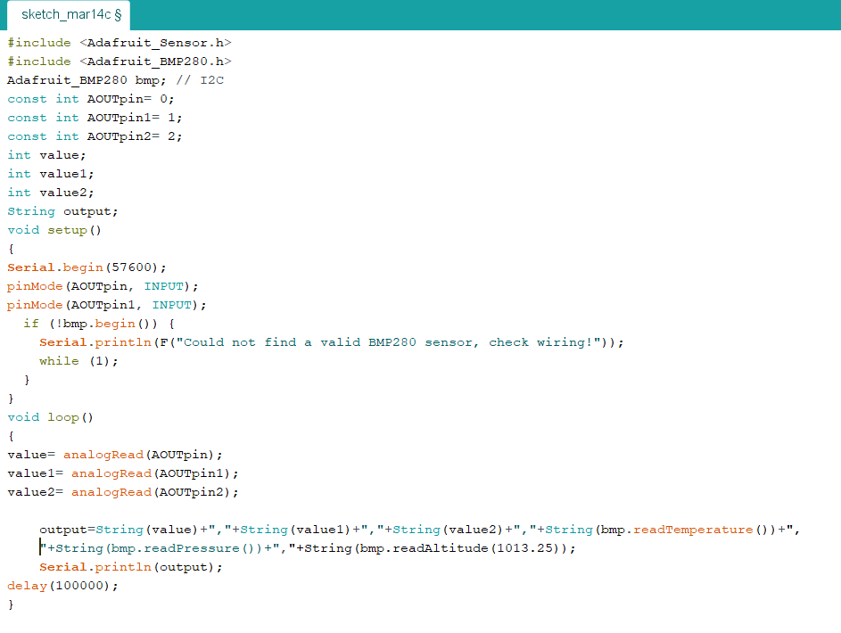

**node-red flow**

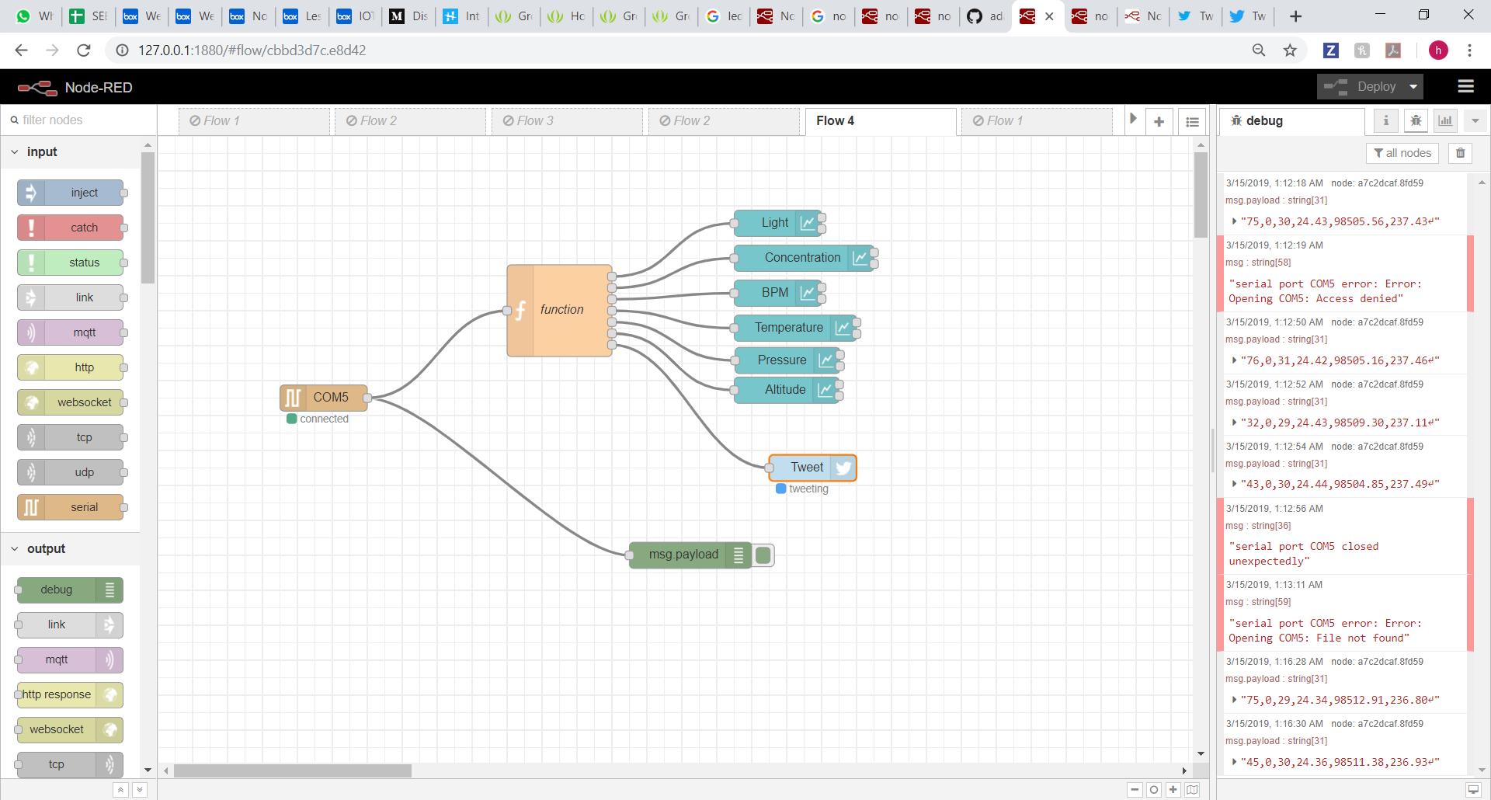

**twitter**

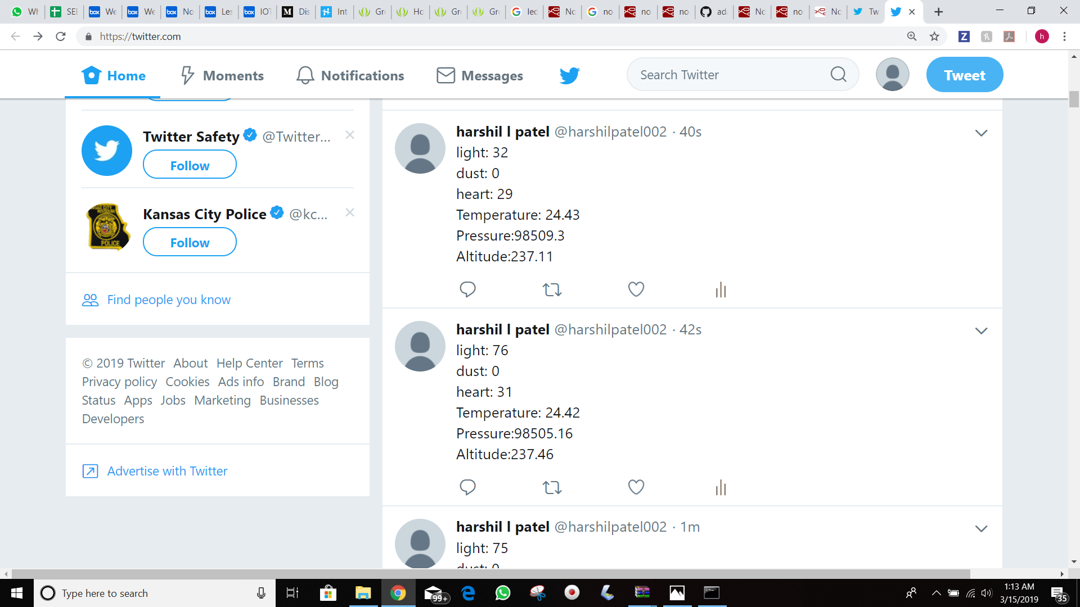

**conclusion**

with the help of this assignment we where able to learn...

1. connecting multiple sensor with arduino.
2. link arduino with node-red and collecting serial output of arduino.
3. posting the collected data in form of tweet in twitter.